**MUSIC**

1. **Abstract**

MUSIC is a website about music production company. Introducing its events and music genres.

1. **User manual**

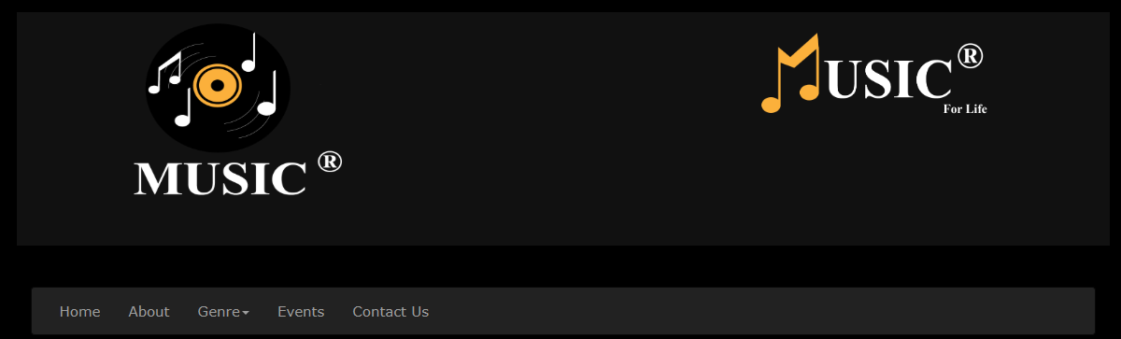

All Pages include:

The header which has two logos designed by Adobe illustrator for the MUSIC company and its website.

Followed by nav bar make the transition between the website pages easier (Home, About, Genre, Events, Contact Us).

And end with a footer for copy rights.



* 1. **Home**



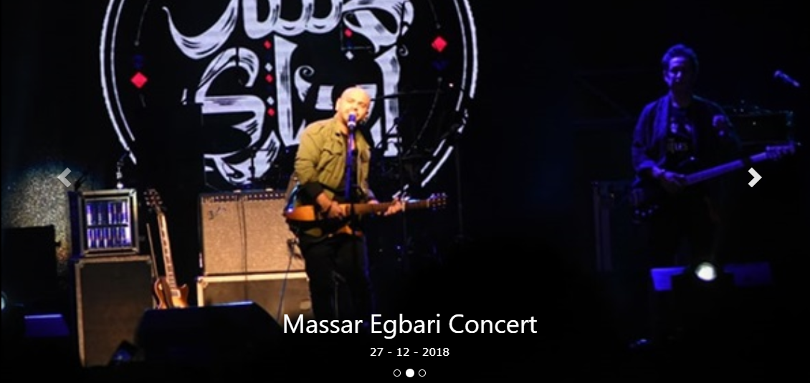

Starts with a carousel with 3 concerts for 3 bands with the date of all of them.

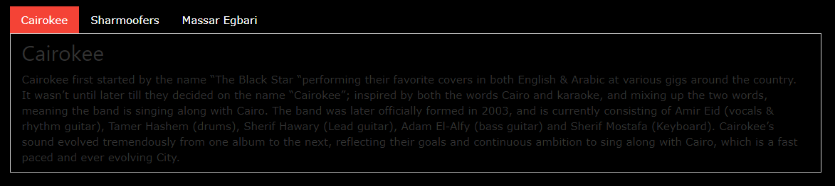

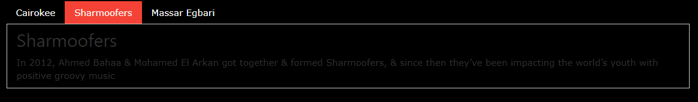

Followed by a short description about each band with bar to make transaction easier.

* 1. **About**

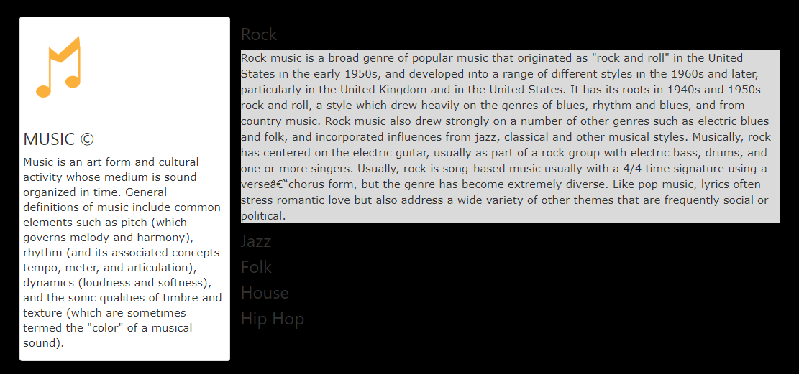

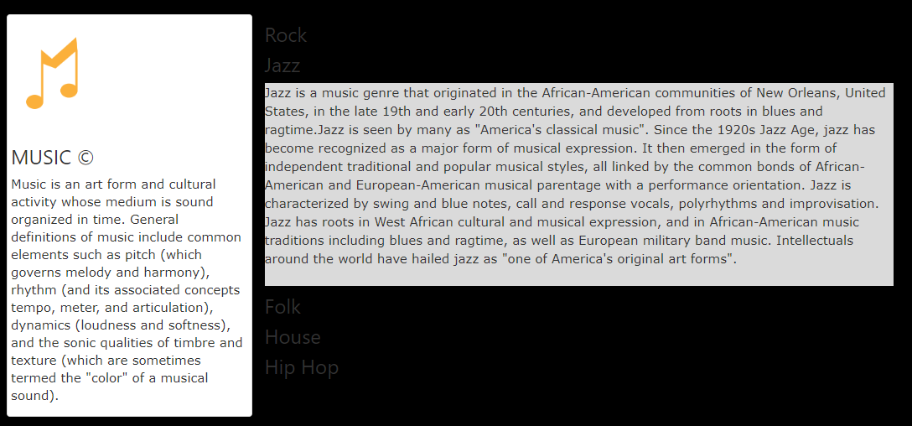

About page has an accordion with five music genres and short description about each one.

With an aside for MUSIC short description and Logo.

* 1. **Genre**

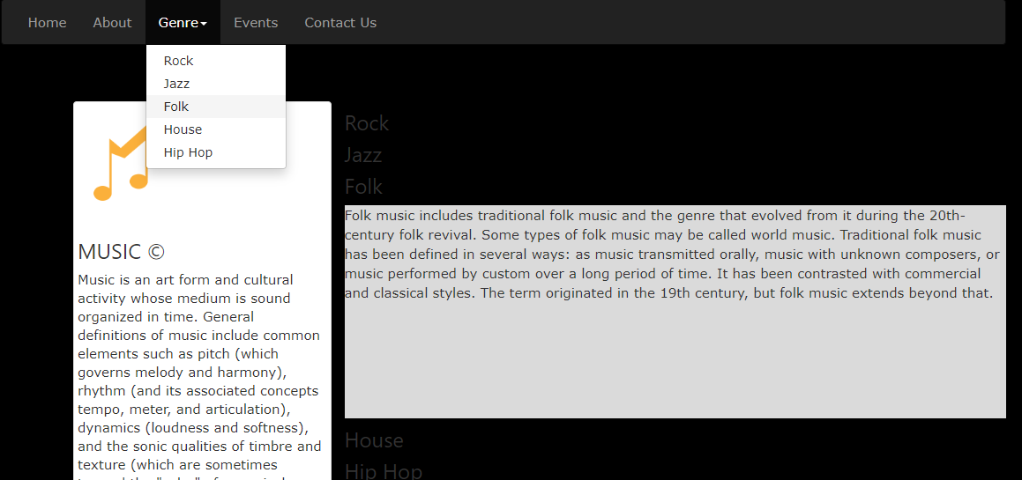

Genre is a list with the five music genres for easier transaction.

* 1. **Events**

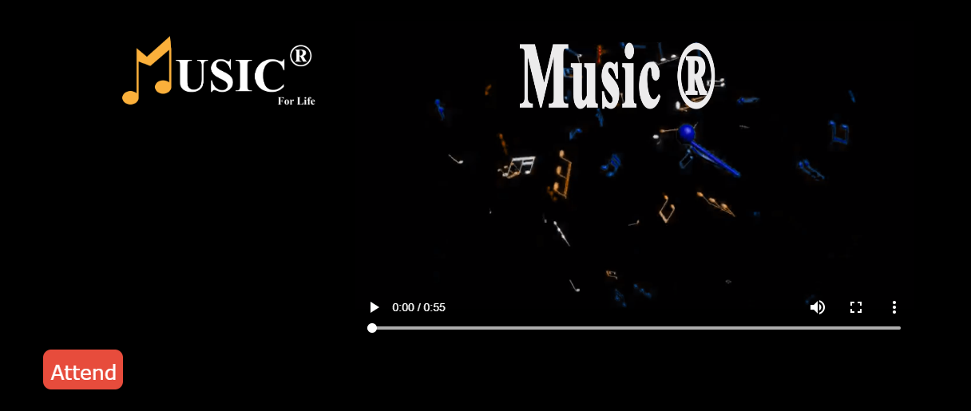

Events Page Starts with a video designed by Adobe after effect to announce the new concert of MUSIC.

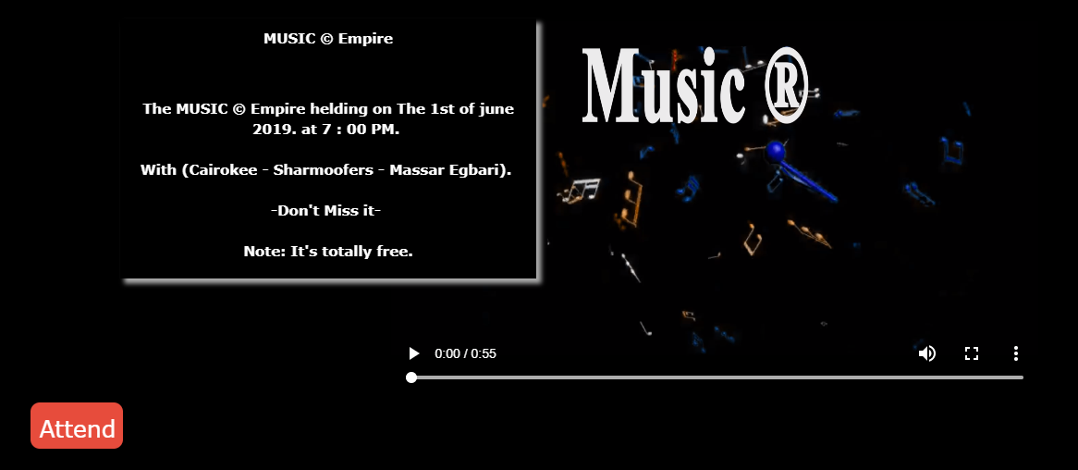

If you clicked the logo of MUSIC in the left. You will get all the details about the concert.

And If you clicked the shacked button Attend you will move to the reservation page.

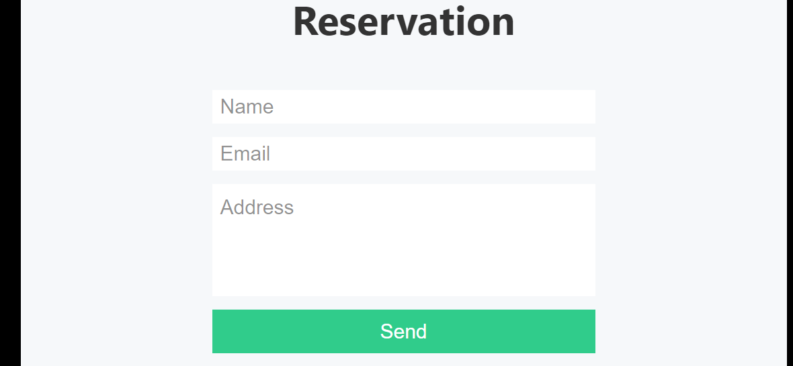

After filling all of your data. You will move to your online ticket page.



* 1. **Contact Us**

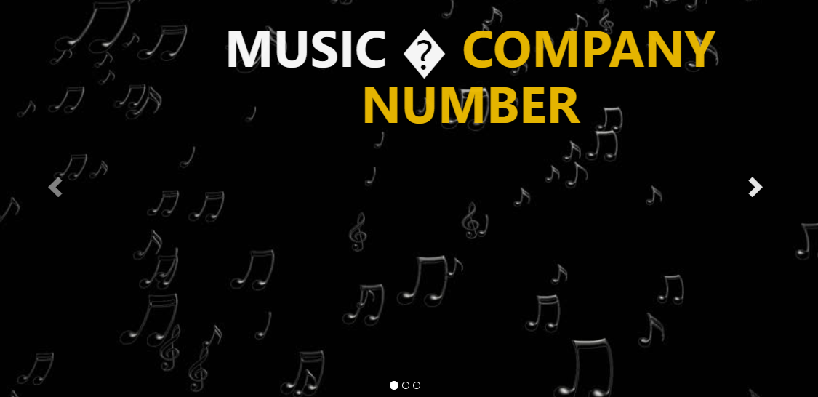

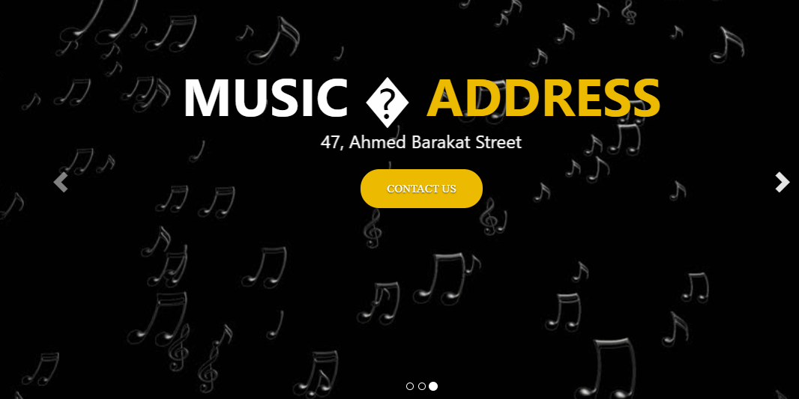

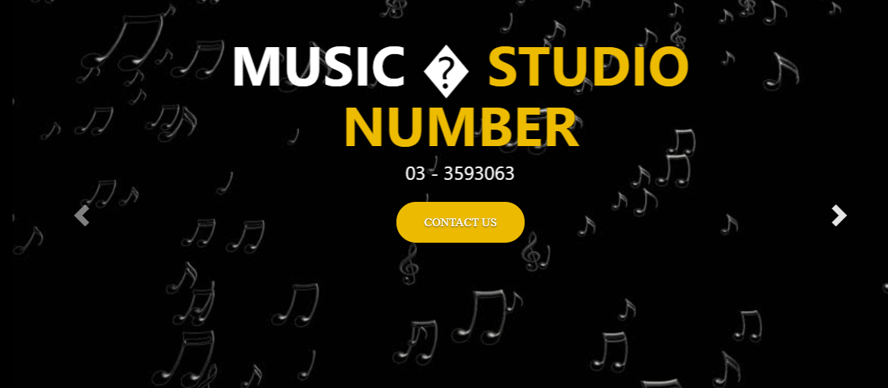

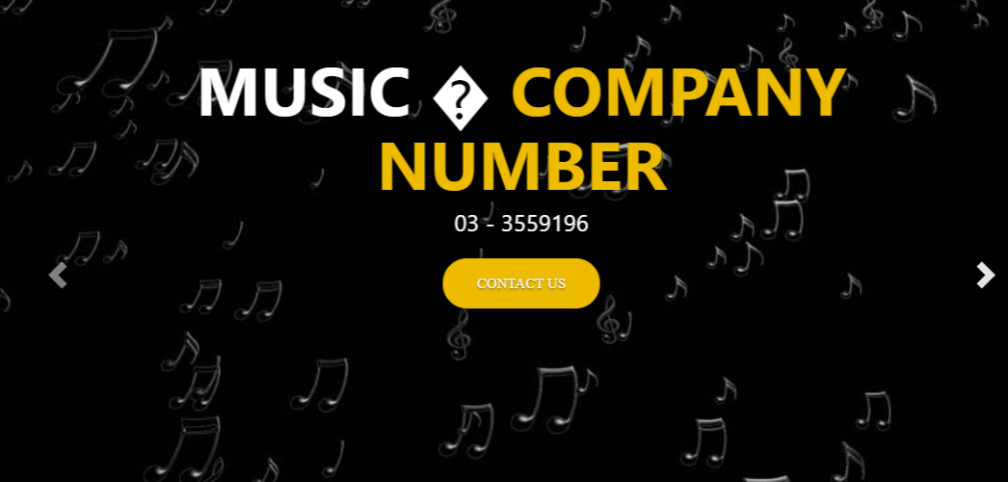

Contact Us page has a carousel of 3 slides having the Company number, Studio Number, Address of MUSIC production company and contact us button all animated with animate.css.

*************************************************************

**Name: Gehad Assad Abo El-Abass Mohamed.**

**ID: 20161439649.**